db.products.find();

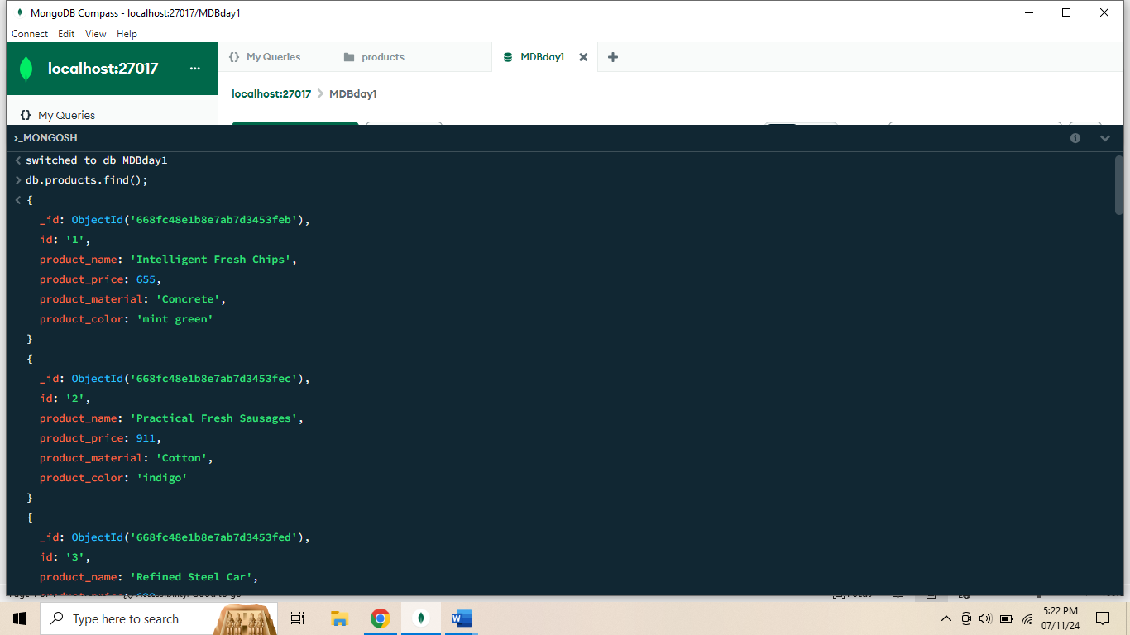

db.products.find({product_price:{$gt:400,$lt:800}});

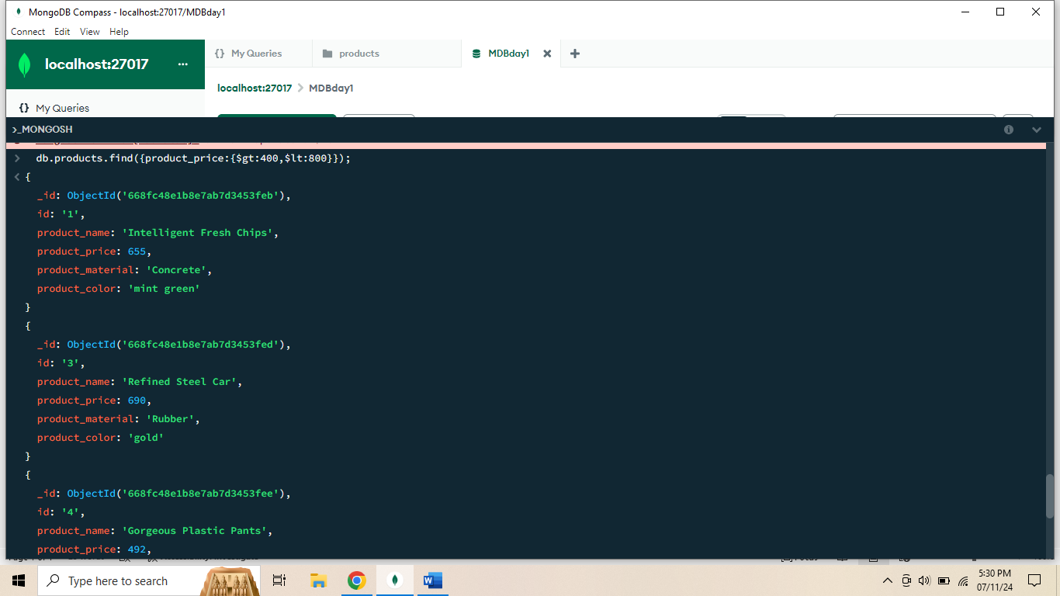

db.products.find({product_price:{$not:{$gt:400,$lt:600}}});

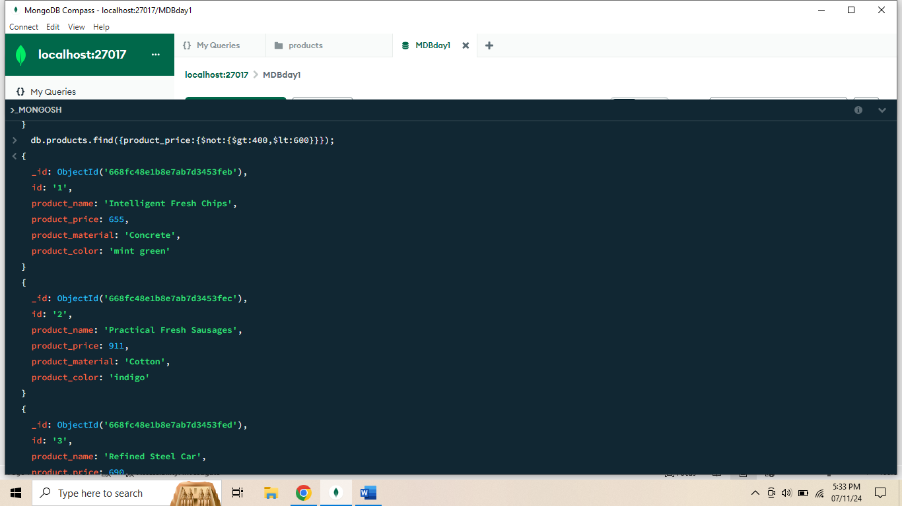

db.products.find({product_price:{$gt:500}}).limit(4);

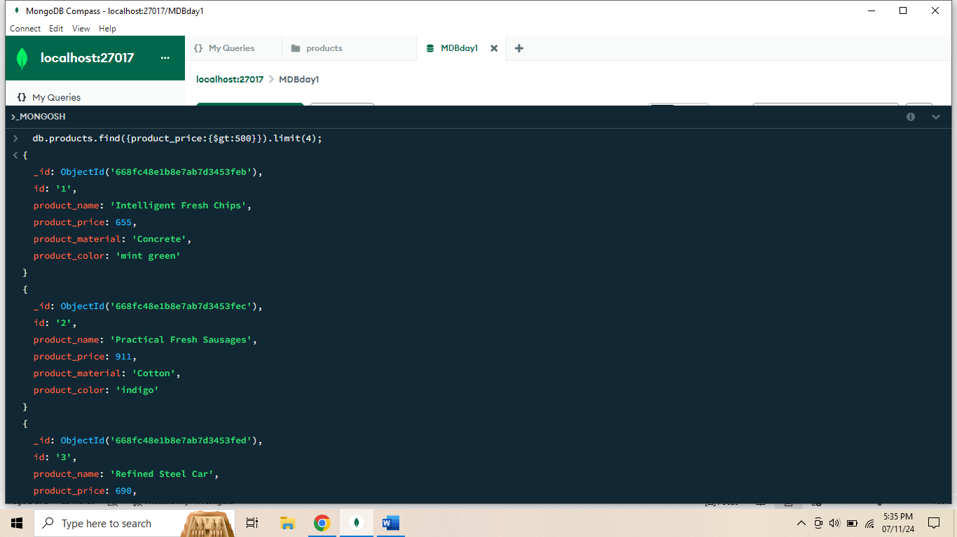

db.products.find({},{product_name:1,product_material:1});

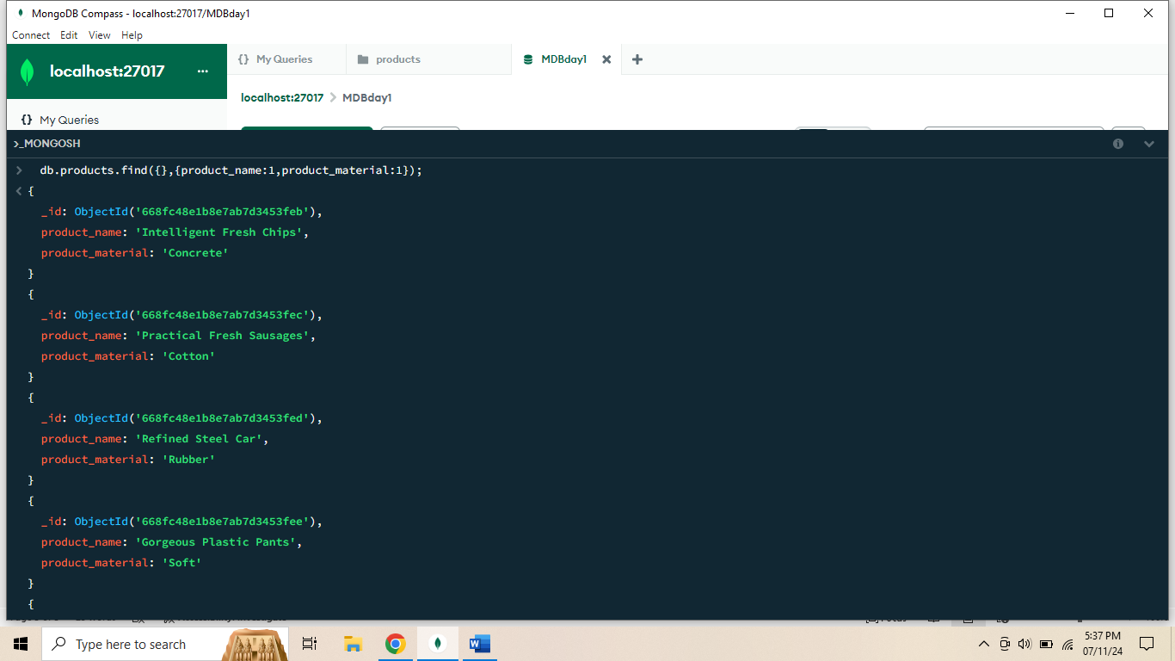

db.products.findOne({“id”:”10”});

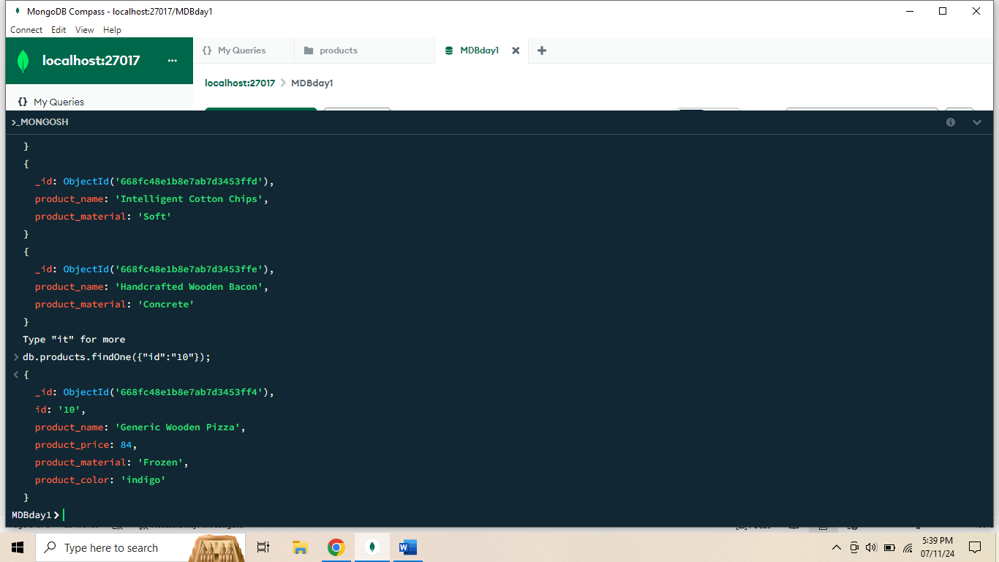

db.products.find({},{product_name:1,product_material:1,_id:0});

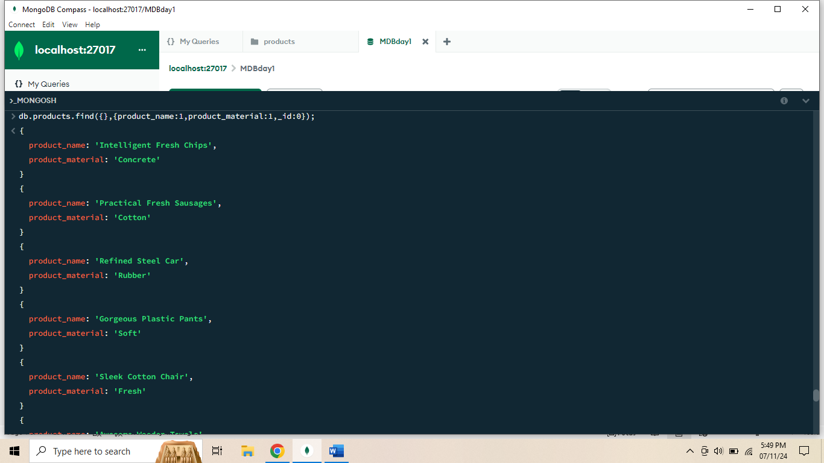

db.products.find({ "product_material": /soft/i });

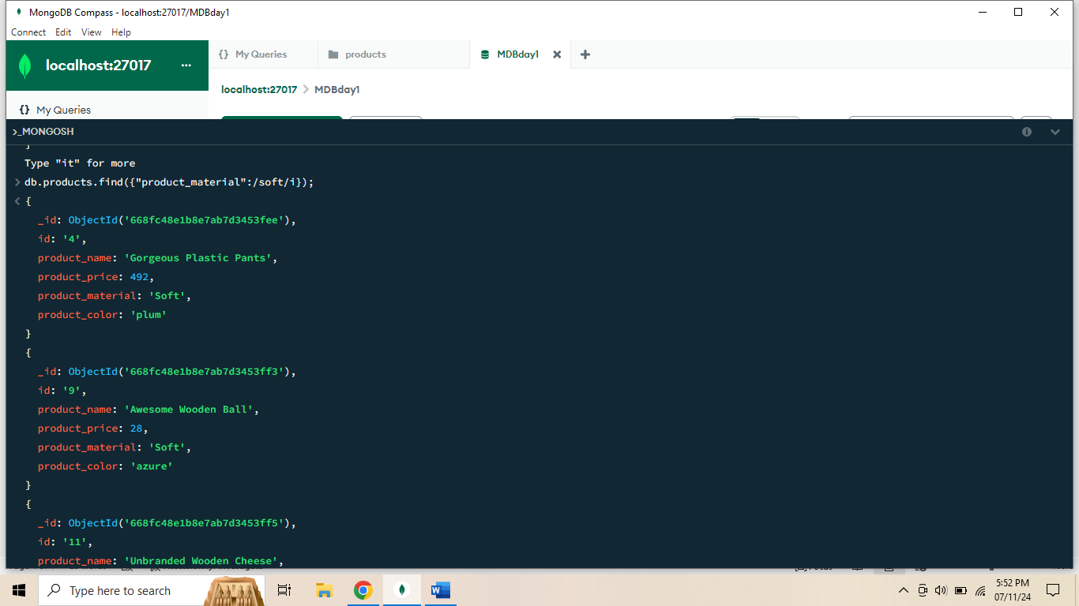

db.products.find({$or:[{ "product_color": "indigo"},{ "product_price": 492.00}]});

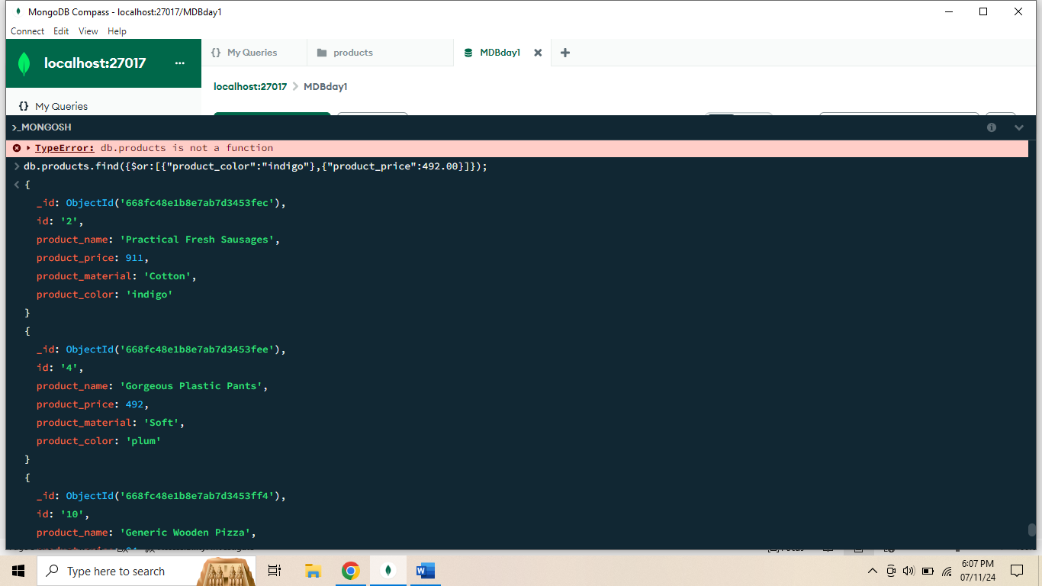

db.products.deleteOne({“product_price”:{$eq:28.00}});

